**Project Design Phase**

**Solution Architecture**

|  |  |
| --- | --- |
| Date | 27-06-2025 |
| Team ID | LTVIP2025TMID59564 |
| Project Name | Edututor AI: personalized learning with generative AI and lms integration |
| Maximum Marks | 4 Marks |

**Solution Architecture:**

* Frontend: Streamlit (UI, Tabs, Widgets, Graphs)
* Backend: Python logic + SQLite database
* AI Logic: Rule-based adaptive quiz generator
* State: Managed via st.session_state
* Storage: Local database (edututor.db), secrets via .env

.

**Example - Solution Architecture Diagram:**

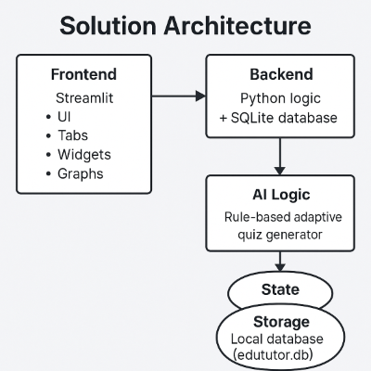

*Figure 1: Architecture and data flow of the application*